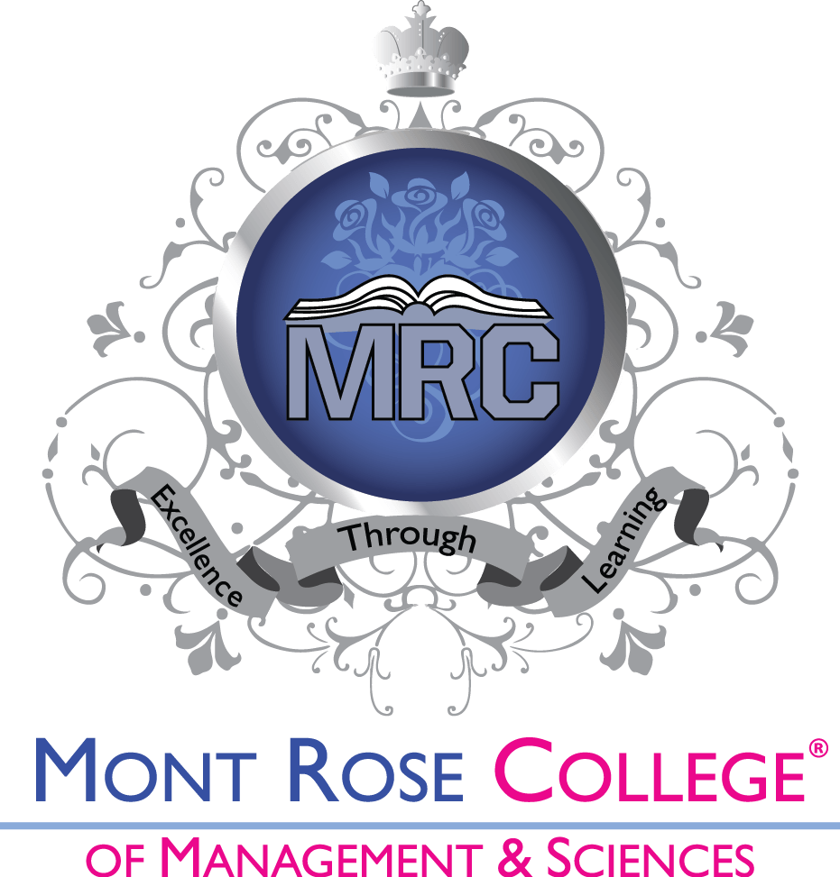

Academic Appeal Policy and Procedure 2020-2021

Approved by: Academic/Quality Assurance Board
Date of approval: March, 2020
Effective date: March, 2020
Next review date: March, 2021

Campus – Mont Rose House, 412-416 Eastern Avenue, London IG2 6NQ
Campus – Shakespeare House, 267 Cranbrook Road, London IG1 4TG
T: 020 8556 5009 F: 020 7998 0517
E: info@mrcollege.ac.uk
www.mrcollege.ac.uk

Introduction

1 This document describes the process for the management of academic appeals for students on all HND and DET courses at Mont Rose College of Management and Sciences (the College). The Top up and Foundation courses are governed by Bucks New University’ policy and procedure in this regard.
2 This appeals process operates within the context of the QAA, UK Quality Code - Advice and Guidance- Concerns, Complaints and Appeals (QAA, 2018) and with reference to the Good Practice Framework for Complaints and Appeals (OIA, 2016) which can be seen at https://www.oiahe.org.uk/media/1859/oia-good-practice-framework.pdf.
3 The College has one appeals process for all academic matters. This process is available on the College website for the benefits of all the students (Guiding Principle 3)
4 No appeal made in good faith, even if unsuccessful, will disadvantage the student. The Team Leaders will ensure that all teachers act in an unbiased way towards all the students (Guiding Principle 3).
5. The procedure is being made amply clear in this document to benefit the students. In case student still find any ambiguity, they should contact their Team Leader/s and if anything is still not clear, the Academics Director (Guiding principle 5, OIA 81).

Academic Appeal defined
An academic appeal is a request that a decision made by either the teacher / assessor or the Internal Verifier be reconsidered on the basis that a mistake has been made and that this has had a significant negative impact on the student.

The permitted grounds for appeal are listed as under:
Decision making body | Permitted grounds
Teacher / Assessor | Procedural irregularity / bias
Internal Verifier | Procedure irregularity
Assessment Board | Mitigating circumstances not made known earlier for valid reasons

No appeal is allowed on academic or professional judgement. However, if a student is of the opinion that the assessor / IV has missed any evidence on the submission, s/he can point out the same for the appeal to be accepted.

An appeal can only be raised on the most recent decision i.e. decision made in the current or last semester. Appeals against the decisions in the semesters prior to last one are not allowed.

1 Purpose and scope of the procedure
  - In all cases the College will abide by the QAA UK Quality Code for Higher Education, Advice and Guidance, Concerns, Complaints and Appeals as well as the OIA Good Practice Framework for Complaints and Appeals.
  - An academic appeal should be made by the student in writing. The College distinguishes between a student complaint (about any non-assessment service provided by the College and/or awarding body) and a student academic appeal. Academic appeals are concerns or problems raised by a student or students concerning any aspect of the assessment process, including grades/ marks given. There is a separate student Complaint Procedure about non-academic matters. It is vital to properly classify the matter as academic or non academic because the procedure for resolution will be based on this classification. The student should clearly set out the subject matter of the appeal and must pin point the areas of deficiency of the College. The student must provide the evidence in support of the appeal and should state the expected outcome. (OIA 87)
  - This academic appeals procedure applies to the students, who would like to appeal against the matters which are in the College control. Any matters raised against awarding bodies, Buckinghamshire New University, or other Mont Rose College partners, should be submitted directly to the relevant bodies. The College representative will provide the full guidance on how to appeal to other relevant bodies. (Guiding principle 2 and 3)
  - During the special situations like COVID-19, the College will provide special relaxations like not capping the grades on late submissions, helping those students upload their work who cannot access Moodle because of their circumstances and providing special encouragement to the non-submitters by contacting them on their emails.

Grounds for an academic appeal (Guiding principle 3)

- ‘Procedural irregularity’

A procedural irregularity is a failure of a decision-making body/ decision maker to follow the process or rules in place for making decisions, or when a decision has been made based on an error of fact.
Examples could include:
•Relevant assessment criteria have been met but not acknowledged. (with proof for such claim)
• An error in recording grade/s; like all P and M criteria have been met but awarded grade is Pass;
•The student was unjustifiably excluded from an examination or an assessment opportunity.
• Work not assessed by an approved assessor;
• Decision-making body / Assessment Board not properly constituted;
•Prejudice or bias on the part of one or more assessors or members with proof of such prejudice.
A procedural irregularity will only be considered grounds for an appeal where the failure has had a material effect on the decision which is being appealed.
Dissatisfaction or disappointment with the result of an assessment or decision of those areas covered within the Academic Appeals process is not sufficient grounds for an academic appeal.

Evidence
For an appeal to be considered there must be evidence supporting the claim.
Admissible evidence must be factual and specific in supporting the grounds for appeal; it might include original versions of:
• assignment feedback forms / formative feedback.
• correspondence (written or email);
• witness statements (which must be dated and signed);
• tutorial record forms;
The decision letter or e-mail notification containing information on which appeal is based must also be provided.
Copies of documents are not normally acceptable. Originals will be copied and returned to the student if requested.
Providing documents that are fraudulent or include unauthorised amendment may cause a student to be referred to the Student Disciplinary Process and/or Fitness to Practise where applicable.
Unsupported claims or unsupported allegations against any individual or group of staff will not be considered. False information or defamatory allegations submitted as part of an appeal can lead to disciplinary action.
- Mitigating circumstances not made known earlier for valid reasons
The student can make an academic appeal on the grounds of mitigating circumstances which were not brought to the notice of the College earlier for valid reasons. Proper evidence should be presented in all such cases. For example, if a student makes an academic appeal outside the permissible time limit of three calendar months and cites the sickness as the reason for the delay, he / she has to present a certificate to this effect from a UK GP.
Time Limit to bring an academic appeal: Any student or ex-student can bring an academic appeal within three calendar months from the issue / event taking place. For example, if a student is unhappy with the grade awarded in a certain module, he / she is free to bring the matter to the attention of the concerned teacher within 3 Calendar months from the date the final feedback was put on Moodle or the result conveyed to the student by the results department whichever is earlier.
The academic appeals process (Guiding principle 5)
The appeals process is divided into three stages, informal, formal and review (Guiding principle 5, 8; OIA 82).
Students are advised that if they are in a referral situation, and have submitted an appeal, they should still complete and submit their referral work within the given time limit.
Appeal submissions should be as clear and concise as possible, concentrating on the grounds for the appeal and linked to the evidence. Other information which does not constitute an appeal, such as a complaint about the level of service provided, should be excluded and the appropriate route followed for these kinds of concerns (Guiding principle 3).

It is the right of a student to withdraw from the appeal process at any time.
However, no student will be put at any disadvantage of any kind just on the grounds of bringing an academic appeal (Guiding principle 6, 7)

Stage 1 – Informal Academic appeal
In the first instance an attempt to resolve queries and concerns informally should be made. The student should contact the respective teacher within 5 working days of receiving the decision. It could be verbal or in writing. (Guiding principle 2) The teacher will try to resolve the issue within 2 working days of receiving the same. In case the issue is not resolved, it should be taken up with the respective Team Leader within 5 working days. Students are advised to contact the teacher / Team Leader using their College email id. An effort should be made to solve the issue at this stage. (Guiding principle 8). The Team Leaders will have 14 working days to resolve the matter informally. The student should be given the full opportunity to present their case. (Guiding principle 8). In case the College is not able to meet this time scale, all parties will be kept informed.
The Teacher / Team Leader should keep the student informed at all the stages. At the end, the student should be informed of the outcome in writing.

Stage 2–Formal Academic appeal

If the academic issue is not resolved at the informal stage, it will escalate to formal stage. The student has the bring the matter to the notice of the Academics Director in writing. The College will make an initial assessment of the issue to ensure that the appeal follows the correct procedure and within the deadline [3 calendar months from the day the issue occurred (OIA– 89, 53)]. At this stage, if the complaint is about missing the evidence or original assessor being biased or unqualified to assess (which normally should not be the case), the submission will be marked by a different assessor under the supervision of Academic Director within 14 days of receiving the formal complaint. (OIA 84, 91, 53) In case the 2nd assessor requires to see the student, it will be clearly communicated to the student with the reasons for the meeting (OIA 94, 55) If the 2nd assessor awards a different grade, the submission with the assessment will be forwarded to the IV. The decision of the IV, if not agreed by the student, will escalate to review stage at the College level. It is essential to be clear about exactly what is being investigated to ensure that both the staff member and student understand the purpose and scope of the investigation. (OIA 56)

If the complaint is about not following a particular procedure, the Academic Director will review the case and will take a decision. In case any procedure has not been followed / completed, the Academic Director will direct for the completion of the same before arriving at any decision.

The student can directly submit an academic appeal to the formal stage without going through the informal one. He / she can do the same by clearly mentioning the grounds for such action on an email to the course Leader / Programme Manager. (Guiding principle 6)
The formal appeal process should not take more than 28 days to conclude. (Guiding principle 5)

However, the process may need to be quickened in case the outcome of the appeal affects the future plans of the student, like applying for the University course / Top up or in case the impact of issues raised has detrimental effects on student’s mental health / causes distress. This will also be applicable if time limits of regulatory bodies are shorter than those of the College (Guiding principle 5; OIA , 88).

At the student’s request, the College may issue a Completion of Procedure letter at this stage, clearly stating that the internal process of the College has not been completed i.e. the review stage (Guiding principle 3).

While communicating the decision of the formal stage to the students he / she will also be informed about his / her right to take the matter to review stage along with the grounds and time limit (OIA 102, 103). The student will have a month’s time to take the matter to the review stage. If the student does not take the matter to the review stage within 30 days, the matter will be closed at the College level.

The College will keep a proper record of all the complaints but personal details of the students shall be removed (OIA 127, 128, 129, 105, Guiding principle 4).

Stage 3–Review

If the matter is not resolved at formal stage, it will be taken by the student to the review stage. At this stage the Principal will review the entire case in consultation with the IV, and may direct to carry out the reassessment of the submission. (Guiding principle 6, OIA 85, 112).

In case the matter was about any party being biased, the assessment will be given to unrelated party. The decision reached at the end of this process will be final at the College level. The College will close the matter at this stage. Same will be communicated to the students in writing. In case the student’s appeal is not upheld, the student will be issued a Completion of Procedure letter within 28 days. This will include a clear explanation and reason for the decision (Guiding principle 3, OIA 112, 101).

In case the appeal is upheld, a written outcome will be provided with an explanation on implementation of remedy (Guiding principle 8; OIA 69). If the remedy includes referring the academic appeal back to formal stage for reconsideration, this reconsideration should be completed as soon as possible but within 90 calendar days. (OIA 114, 79).

Involvement of OIA:

If the matter is not resolved even at the review stage, the student will be free to take the matter to OIA. The College will issue the CoP as mentioned above clearly outlining the reasons for not upholding the appeal. The CoP will also clearly mention that the student can take up the matter with OIA within 12 months from that date. (OIA 112-113, 115, 35)

The contact details of the OIA (Office of the Independent Adjudicator) are as under:
Website: www.oiahe.org.uk
OIA
Second Floor
Abbey Gate
57 – 75 Kings Road
Reading
RG1 3AB
Tel: 0118 959 9813
email: enquiries@oiahe.org.uk

Other factors:
The following issues will also be considered in this regard:
- All proceedings should, so far as is practicable, remain confidential. (Guiding principle 7; OIA 116, 117, 32)
- College expects that students, their representatives and all staff members will act fairly, reasonably and respectfully towards one another in this process or otherwise. (OIA 118)
- The students are expected to bring genuine complaints only. Complaints of frivolous nature will not be considered and students will be suitable advised. The College will take suitable action in the following cases:
- A student / students making obsessive harassing or repetitive complaints;
- A student / students unnecessarily pursuing non meritorious complaints;
- A student / students pursuing the complaints in an unreasonable manner;
- A student / students making complaints which are designed to cause disruption or annoyance;
- Any complaint looking for a redress which lack any serious purpose or value.
(OIA 119)

- This policy and procedure is be made available to all the students on the College website. (OIA 122)
- Students with mental health issues can take the help of the College Welfare Department to pursue such complaints. The student will also be encouraged to appoint and authorised representative in such case. (Guiding principle 2; OIA 123)
- Even those students who have no mental health issues can appoint an authorised representative.
- All the staff members, both academic and non-academic will be made aware of this procedure by putting it on the College website. (OIA 135)
- It is possible for the College to hear only those academic appeals which are within the power of the College to remedy. In many cases the appeals procedure of the awarding body will apply, and may be operated entirely by the awarding body (Pearson, Bucks).

- A formal written record of any hearing will be made available to the student.
- Where more than one student has lodged an academic appeal relating to the same, or substantially the same, issue, the academic appeal may be dealt with together in the interests of fair and consistent decision-making.
- If the student’s academic appeal restates an academic appeal that the College is already dealing with, or that it has dealt with in the past, the student will be asked to explain how the new academic appeal differs from the previous one, and either what new incident has occurred or what new evidence has come to light.
- Where it is clear that there is nothing new being raised, the College can reject the academic appeal without a hearing or committee meeting.
- An academic appeal raised while a student is subject to disciplinary proceedings will be heard when the disciplinary process has been completed. If the academic appeal has any bearing on the disciplinary proceedings, it can be raised in the course of those proceedings. (Guiding principle 8)

Hearings:
During the appeal process, if any hearings are arranged, the student making the appeal should ensure that he / she attends such hearings at the specified time. If he / she is unable to attend because of circumstances beyond his / her control, they should inform the Principal and/or the chair of the panel as soon as possible. If they fail to attend without explanation, or it appears that they have not made sufficient attempts to attend, the hearings may take place in their absence.
Refusal of any party to attend shall not invalidate the proceedings.
The panel, in seeking to resolve the academic appeal, may adjourn the meeting or defer a decision if more information is required.
There will be occasions when the student who has appealed an academic decision will be invited for a hearing by a panel which will be independent of original assessor/IV. Such panel shall conduct the proceedings as follows:
- Ask the student to present their case, allowing the investigating officer or respondent to ask questions after the presentation has been completed.
- The student may call witnesses or refer to documents previously circulated and necessary for the hearing
- While the student making the appeal will be given every opportunity to explain their case fully, they should confine their explanation to matters that are directly relevant to the academic appeal.
- The chair of the panel will intervene if he/she thinks that the discussion is straying too far from the key issue(s).
- The chair may also intervene to ensure that the meeting can be completed within a reasonable timeframe, depending on the nature and the complexity of the academic appeal
- Ask the investigating officer or respondent to respond to the case, allowing the student to ask questions after the presentation has been completed.
- The investigating officer or respondent may call witnesses or refer to documents previously circulated and necessary for the hearing.
- The panel may ask questions on points of clarification at any time and may call witnesses. Questions shall be put to each party after it has presented its case.
- If either party wishes to present evidence not previously circulated the hearing may be adjourned to allow the other side to consider it.
- Allow the student and then the investigating officer or respondent the opportunity to sum up their cases. Neither party may introduce new matters in their summing up.
- During any kind of crisis situation, (like Covid-19) when physical hearings are not possible, an effort will be made to complete such processes /hearings through online meeting software.

Guidance for appeal documentation / recordkeeping:
The College will make sure to keep the record properly in case of academic complaints. The following is the list of important documents in chronological order: (the same is not exhaustive as the documents differ on case to case basis)
- Student’s original complaint, duly dated with any evidence to support the complaint;
- The date the complaint is received – informal stage;
- The outcome sought / expected;
- Management’s version at informal stage;
- Outcome of informal stage with date;
- Date appeal received at formal stage, if any;
- Grounds of appeal – formal stage;
- Response to grounds of appeal- formal stage;
- Case statement, which should include, as appropriate;
- An introduction explaining the reasons for appealing;
- Summary of case;
- Record of hearings, if any.
- Outcome of appeal, with date;
- If applicable, comments of original assessor, 2nd assessor and IV.
- Date CoP issued, if any;
- Date review requested, if any;
- Outcome of Review;
- Date of CoP after Review;
- Outcome at OIA level.
(Guiding principle 3)
If documents are prepared and presented in this way it should be possible for the secondary appeal hearing only to hear any specific comments or particular aspects of the case, rather than a repetition of the original hearing.
The policy is reviewed and approved by Academic/ Quality Assurance Board annually for enhancement purpose. (Guiding principle 2, 8).
Link to the OIA document:
https://www.oiahe.org.uk/media/1859/oia-good-practice-framework.pdf.

