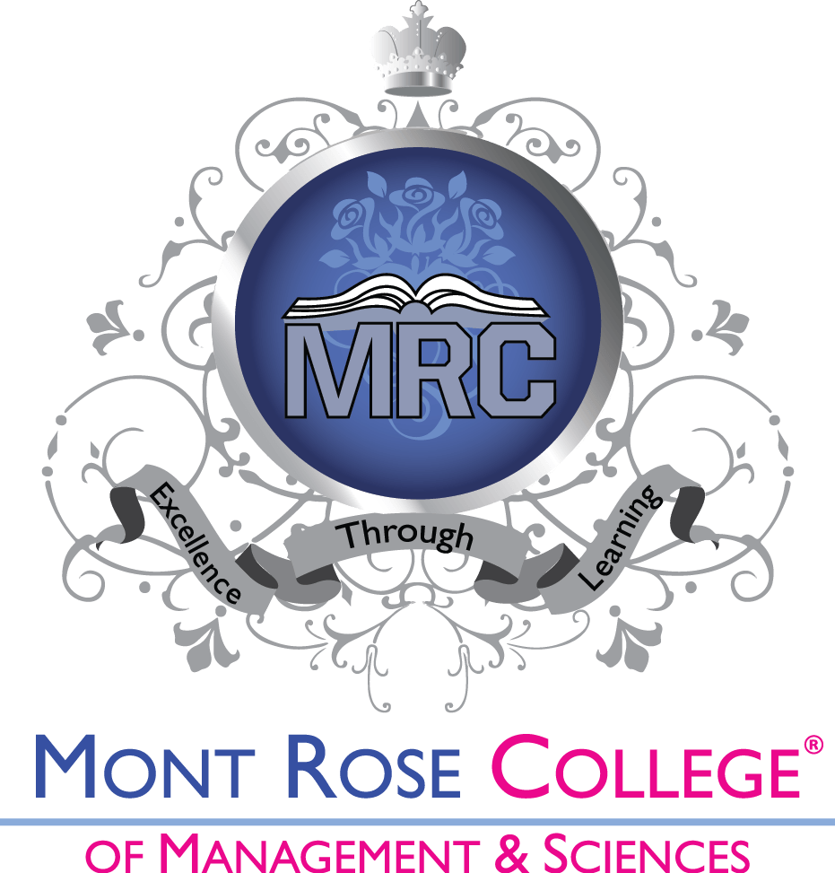

Student Finance and Brexit
2020-2021

Approved by: Academic/Quality Assurance Board
Date of approval: March, 2020
Effective date: March, 2020
Next review date: March, 2021

Campus – Mont Rose House, 412-416 Eastern Avenue, London IG2 6NQ
Campus – Shakespeare House, 267 Cranbrook Road, London IG1 4TG
T: 020 8556 5009 F: 020 7998 0517
E: info@mrcollege.ac.uk
www.mrcollege.ac.uk

Brexit information for existing and new students:

We understand that EU students who want to study in the UK may be concerned about the eligibility for the student loan and immigrations issues from December 2020; therefore, we gathered some information and answers to the FAQs. If you cannot find your answers here, please email us at nosheen@mrcollege.ac.uk
Students applying for 2 years HNDs, 1-year Top-up degrees, DETs, or 4 years foundation degrees anytime during 2020-21 will be able to complete their courses regardless of course length (2,3 or 4 years).

The UK government has announced that EU, EEA and Swiss students commencing their studies in 2020-21 Academic year or before will be eligible for “Home Fee Status” and financial support for the duration of the course as long as they meet the eligibility criteria. (Source-Gov.UK) Your rights to live in the UK will not change until 31stDecember 2020. All citizens of the EU, Iceland, Liechtenstein, Norway, and Switzerland who are living in the UK before 31st December 2020 will be able to apply to the EU Settlement Scheme (EUSS). The EUSS means citizens of the EU, Iceland, Liechtenstein, Norway, and Switzerland will be able to stay and continue to access benefits and services broadly on the same terms as now. This service is free of charge. The deadline to apply for the EU settlement scheme is until 30th June 2021. Successful applicants will receive “settled” or “pre-settled” status depending on the duration they have been living in the UK. (Gov.UK) Continue living in the UK website is created on Gov.UK for more information. There is also a step by step guide on applying the EU settlement scheme by the UK government. (Gov.UK) More information about getting student finances could be found here: https://www.gov.uk/student-finance/who-qualifies?step-by-step-nav=18045f76-ac04-41b7-b147-5687d8fbb64a

FAQs:
What impact will Brexit have on the Tuition fee, Maintenance Loan and Grant?
The UK government has announced that EU, EEA and Swiss students commencing their studies in 2020-21 Academic year or before will be eligible for “Home Fee Status” and financial support for the duration of the course as long as they meet the eligibility criteria.(Gov.UK)
I am an EU student, currently studying at Mont Rose College of Management & Sciences, will Brexit affect the remainder of my studies?
EU students who are already receiving the student loans will be continuing to receive the student loan for the remainder of their studies; regardless, they are on the 1st, 2nd, 3rd year of their course.
I am an EU student living in the United Kingdom; what do I have to do to stay in the UK after the Brexit?
If you wish to continue living in the UK, you must apply for the EU Settlement Scheme. The deadline to apply for this scheme is 30th June 2021. If your application is successful, you will be given either a “settled” or “Pre settled” status, depending on how long you have been living in the UK when you apply.
Will, there be a change in regulation concerning students that were approved for SF under the ‘migrant worker’ category (increase in working hours’ threshold?)
There will be no effect on current students and students starting their courses in the 2020-21 academic year. It is not clear if it will change for 2021-22.
Moving abroad – will repayments be affected by the exchange rates?
The exchange rates will not affect the repayments. SLC will apply discretion.
Will the expiry date for unpaid loans remain the same (30 years)?
The loans are written off after 30 years anniversary when the loans enter repayment status.

